Assignment#1

Name : Nayyab batool.

Roll number : 18th.

Semester : 1st.

Department : software engineering.

Subject : pf.

Submitted to : engr zeeshan Rashid.

(Q1): installation wizard of IDE,(DEVC++).

(A):(1)open Google and type DEVC++download in the search bar.

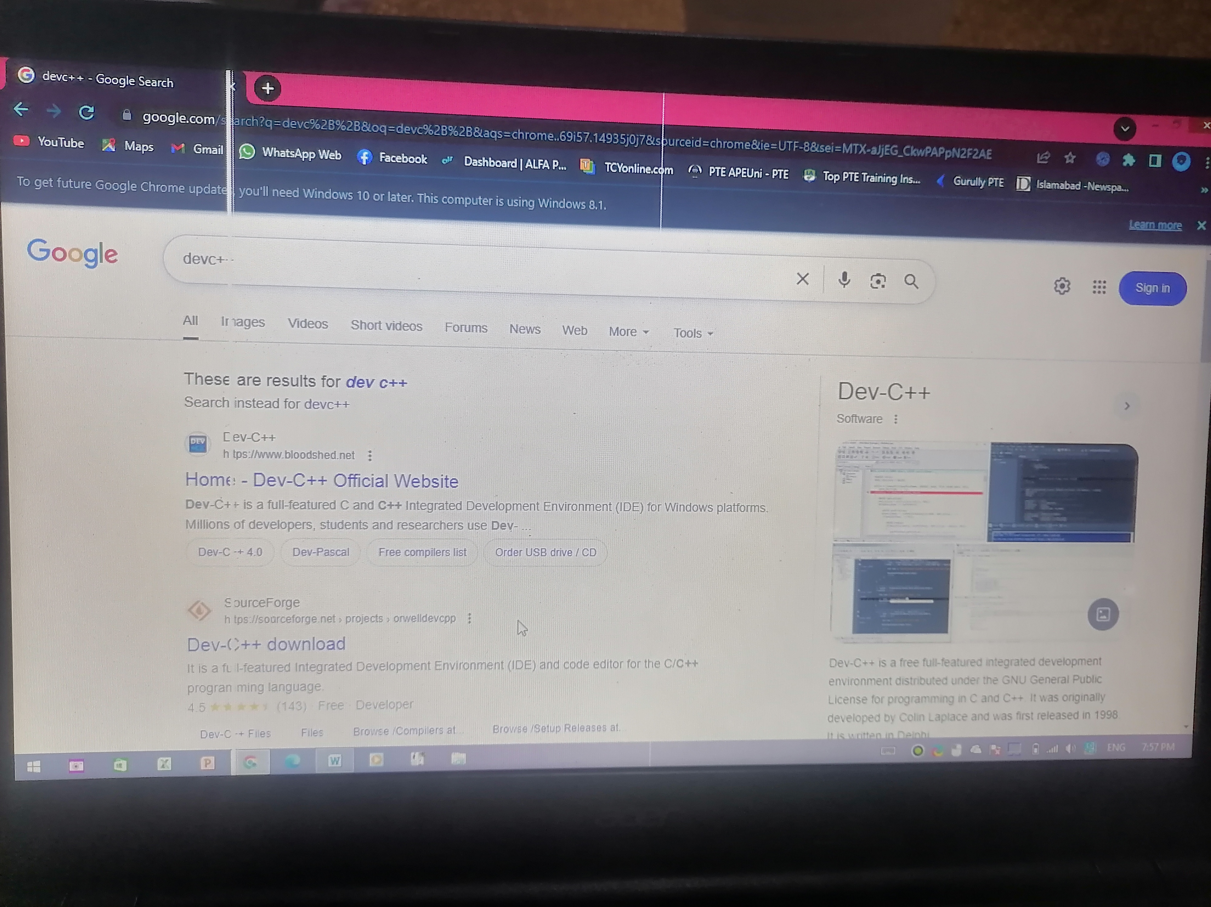

(2): click on the first website there ;there we will get the documents option ;download it from there.



(3):after that the official website of DEVC++ will appear, and from there you will get the option to download it.

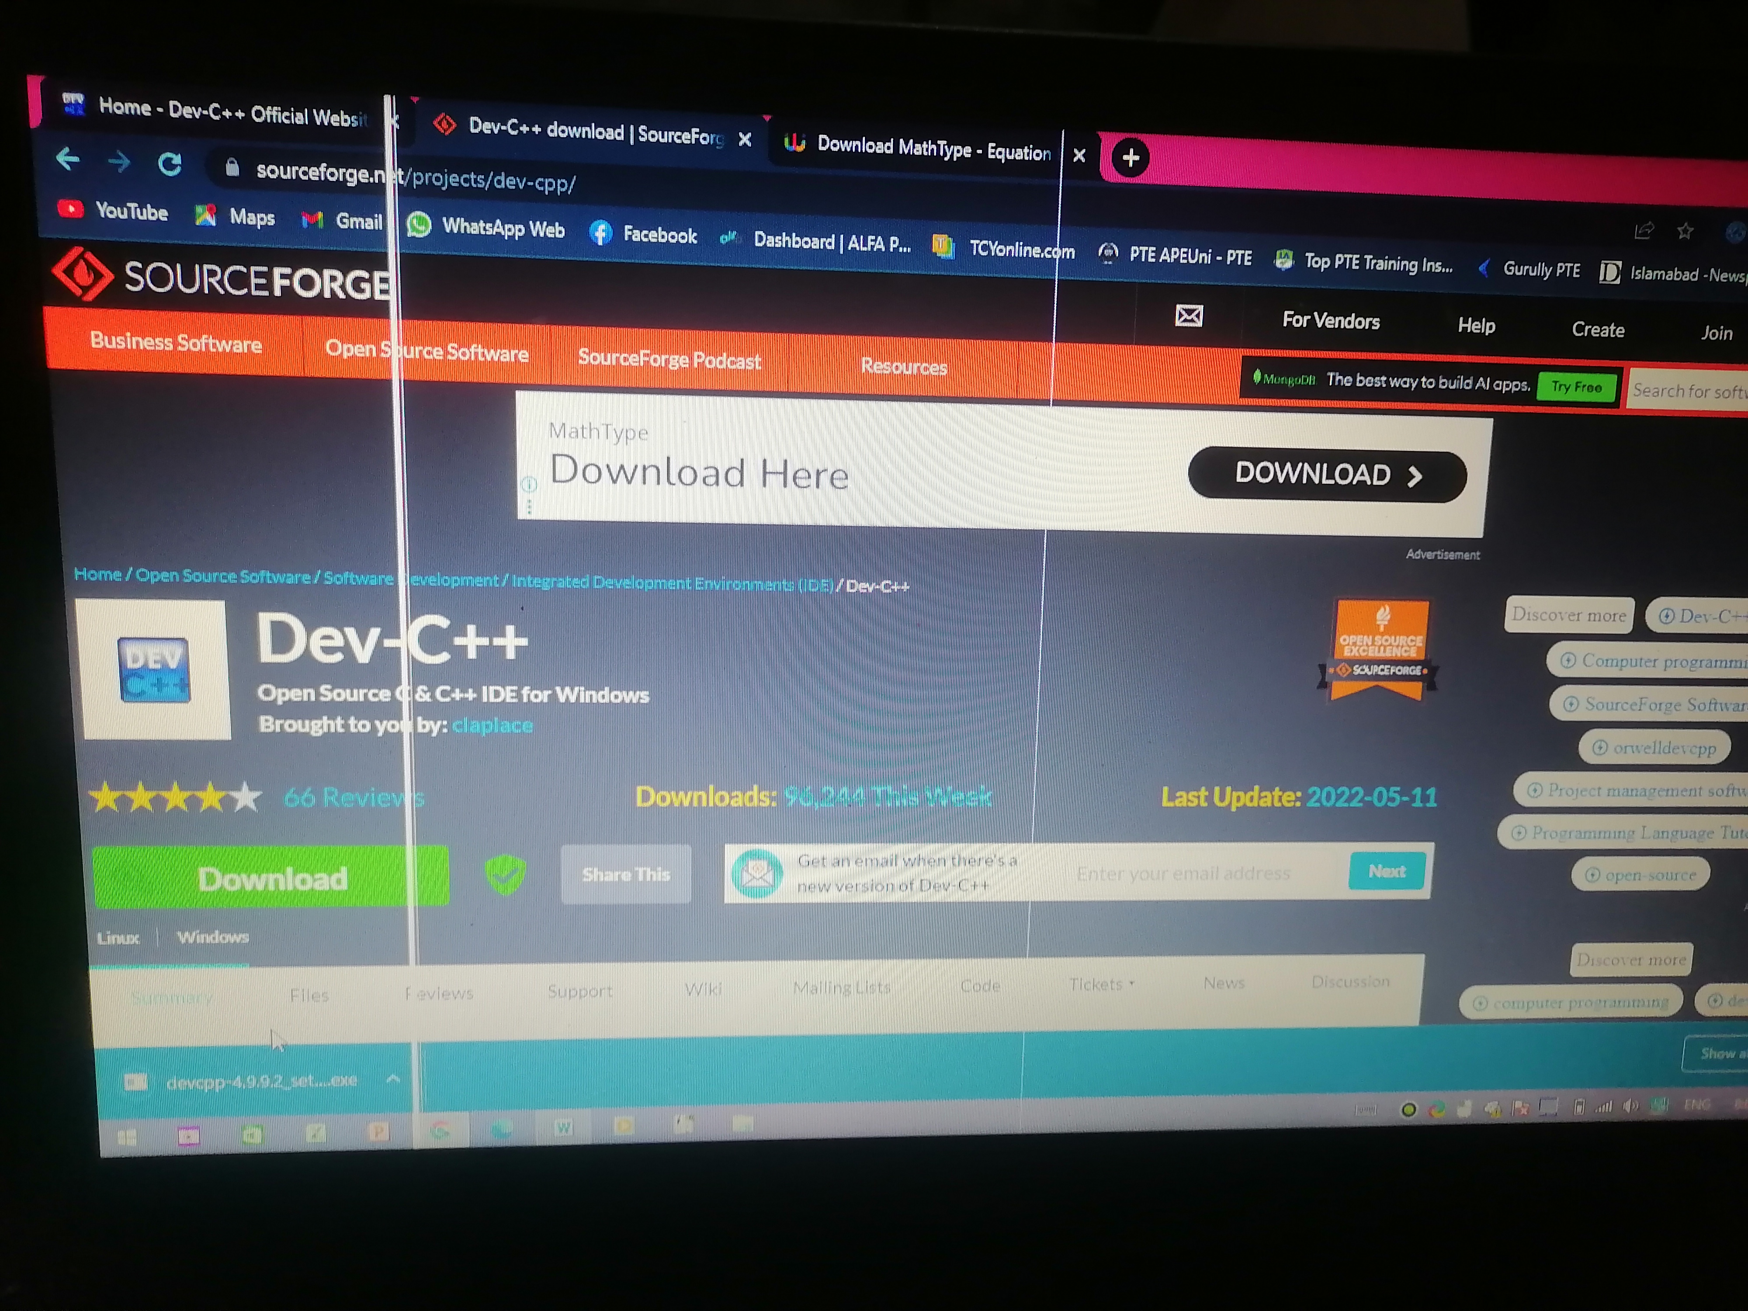

(4): when DEVC++ has finished downloading, it will show you an agree option you need to click on that.

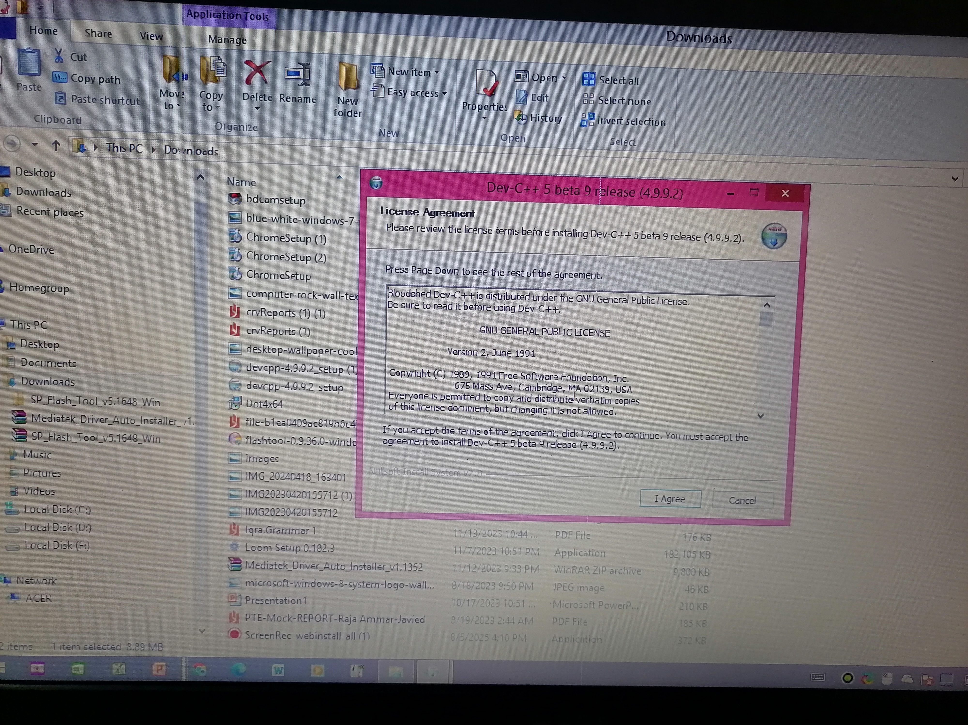

(5):When DEVC++ has finished downloading, it will give you an option to choose your components.

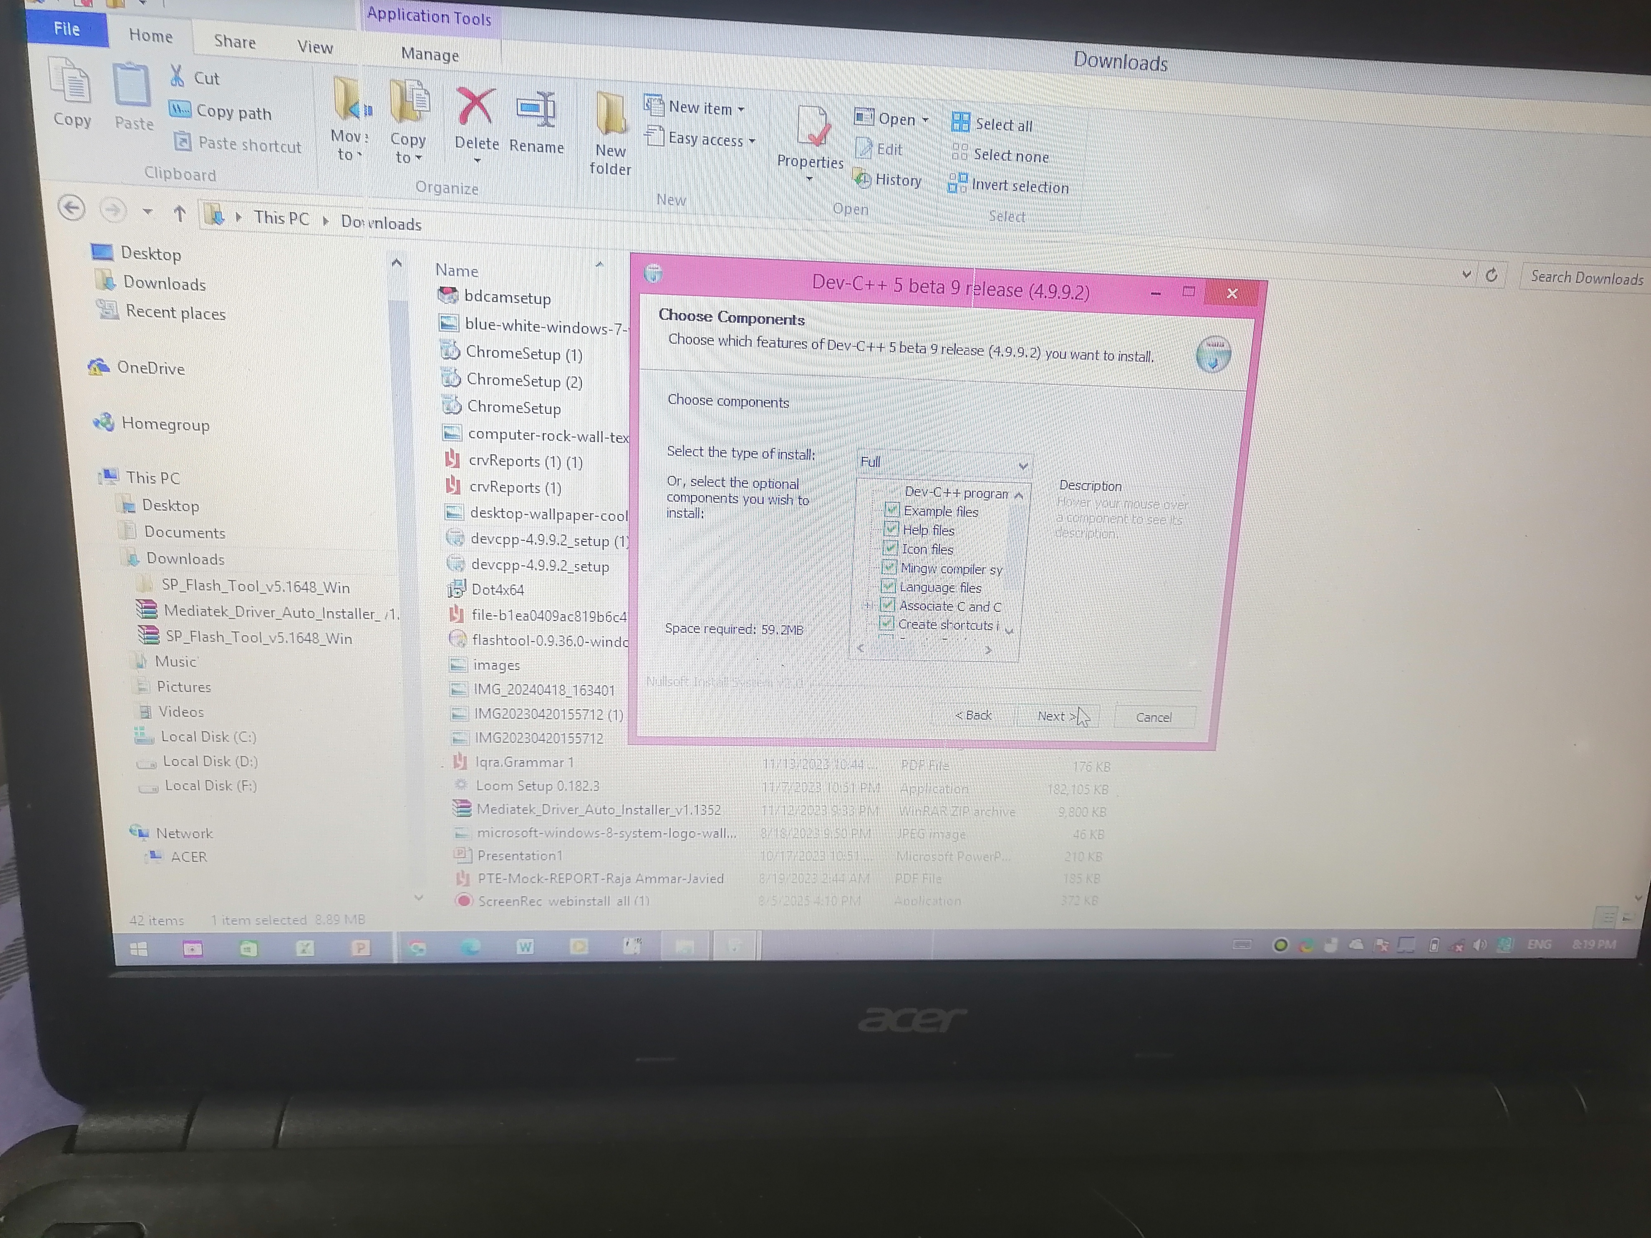om

(6):After that, you will have to wait for one minute until the application finishes downloading.

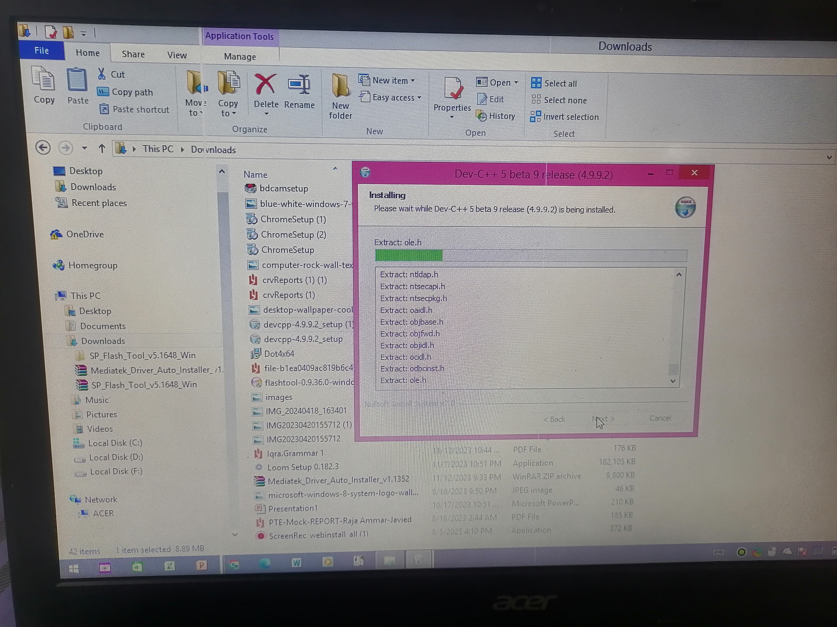

(7):after completing these 8 steps, DEV++ will be fully downloaded on your computer.

